1. **Undertake the following exercise from the perspective of a stakeholder in your case study.**

**What is your Business?**

My business is “**Business Aviation (NYAirlines)**”. It is the use of some aircraft for a business purpose. It provides communities large and small with fast, flexible, safe, secure and cost-effective access to destinations across the country and around the world.

**Who is the Stakeholder?**

In my case, there are 2 key stakeholders. They are:

1. **Airport Management Authority.**
2. **Customer Care Department**

**What is your KPI?**

Key performance indicators (KPIs) of my business are:

1. **To deliver a quality service.**
2. **Ensure Customer Satisfaction**

**List & clarify relevant business question(s) that need to be answered for the Investor**

**Business Questions related to Quality Service KPI**

* How many flights which are delayed per year?
* How many flights diverted per year?
* What’s the number of arrival delays per year?
* What’s the number of departure delays per year?
* What’s the number of flights cancelled per year?
* What are the reasons behind flight cancellation?

**Business Questions related to Customer Satisfaction KPI**

* What are the different complains of a customer?
* How many complains are resolved in the span of one year?
* What the different types are of complains from the customer?
* What is the total number of compensation per complaint type per year?
* What is the compensation type offered to customers?

**What current tables and columns are required to answer questions above?**

For questions related to **Quality Service KPI**, we need **“Flights_2015_2000_rows (table)”** with the following columns.

* YEAR
* FLIGHT_NUMBER
* DEPARTURE_DELAY
* ARRIVAL_DELAY
* DIVERTED
* CANCELLED
* CANCELLATION_REASON

For questions related to **Customer Satisfaction KPI**, we need **“COMPLAINT_NYAirlines (table)”** with the following columns.

* COMPLAINT_TYPE
* DESCRIPTION
* COMPLAINT_STATUS
* COMPENSATION_AMNT
* COMPENSATION_TYPE

**What dimensions that would hold the values (attributes) identified above?**

The dimension that will hold the values (attributes) identified above are:

* COMPLAINT_NYAirlines (table)
* Flights_2015_2000_rows (table)

**Identify lowest level of granularity (for each Dimension)**

**For Flights_2015_2000_rows (Table)**

* Arrival_Delay and Departure_Delay will become **total_delay_time.**
* Elapsed_Time and Air_Time will become **total_time**.
* Air_System_Delay, Security_Delay, Airline_Delay, Late_Aircraft_Delay, Weather_Delay will become **Total_Delay**

**For COMPLAINT_NYAirlines (Table)**

The_Year, The_Month, The_Day will become **Date.**

**Identify the measures (calculations or facts) to support the business questions (your reports)**

**Measures related to Quality Service KPI**

* Total flights delayed per year
* Total flights diverted per year
* Total arrival delays per year
* Total departure delays per year
* Total flights cancelled per year
* Reasons behind flight cancellations

**Measures related to Customer Satisfaction KPI**

* Different complains of a customer
* Total complains resolved per year
* Reasons behind customer complains
* Total compensation per year
* Compensation type offered to customers

**Define (name, data type) suitable attributes of the Dimension tables**

**COMPLAINT_NYAirlines Table:**

1. COMPLAINT_ID(**int)**
2. FLIGHT_ID_NO(**int)**
3. TAIL_NUMBER**(varchar)**
4. THE_YEAR**(DateTime)**
5. THE_MONTH**(DateTime)**
6. THE_DAY**(DateTime)**
7. COMPLAINT_TYPE**(text)**
8. DESCRIPTION**(text)**
9. COMPLAINT_STATUS**(text)**
10. ALLOCATED_TO**(varchar)**
11. COMPENSATION_AMNT(**int)**
12. COMPENSATION_TYPE(**int)**
13. FK1_CUSTOMER_ID**(varchar)**

**Flights_2015_2000_rows Table:**

1. Flights_2015_key **(int)**
2. YEAR**(DateTime)**
3. FLIGHT_NUMBER(**int)**
4. TAIL_NUMBER**(varchar)**
5. ORIGIN_AIRPORT **(text)**
6. DESTINATION_AIRPORT **(text)**
7. SCHEDULED_DEPARTURE**(DateTime)**
8. DEPARTURE_TIME**(DateTime)**
9. DEPARTURE_DELAY**(DateTime)**
10. TAXI_OUT**(DateTime)**
11. WHEELS_OFF**(DateTime)**
12. SCHEDULED_TIME**(DateTime)**
13. ELAPSED_TIME**(DateTime)**
14. AIR_TIME**(DateTime)**
15. DISTANCE**(int)**
16. WHEELS_ON**(DateTime)**
17. TAXI_IN**(DateTime)**
18. SCHEDULED_ARRIVAL**(DateTime)**
19. ARRIVAL_TIME**(DateTime)**
20. ARRIVAL_DELAY**(DateTime)**
21. DIVERTED **(text)**
22. CANCELLED **(text)**
23. CANCELLATION_REASON **(text)**
24. AIR_SYSTEM_DELAY **(text)**
25. SECURITY_DELAY **(text)**
26. AIRLINE_DELAY **(text)**
27. LATE_AIRCRAFT_DELAY **(text)**
28. WEATHER_DELAY **(text)**

**Define (name, data type) the Fact table (keys and measures)**

**Fact Table Keys:**

* Flights_2015_key **(int)**
* Complaint_id **(int)**

**Fact Table Measures:**

* Total flights delayed per year **(int)**
* Total flights diverted per year **(int)**
* Total arrival delays per year**(int)**
* Total departure delays per year**(int)**
* Total flights cancelled per year **(int)**
* Reasons behind flight cancellations**(text)**
* Different complains of a customer**(text)**
* Total complains resolved per year**(int)**
* Reasons behind customer complains**(text)**
* Total compensation per year**(int)**
* Compensation type offered to customers**(text)**

**Draw the Star Schema**

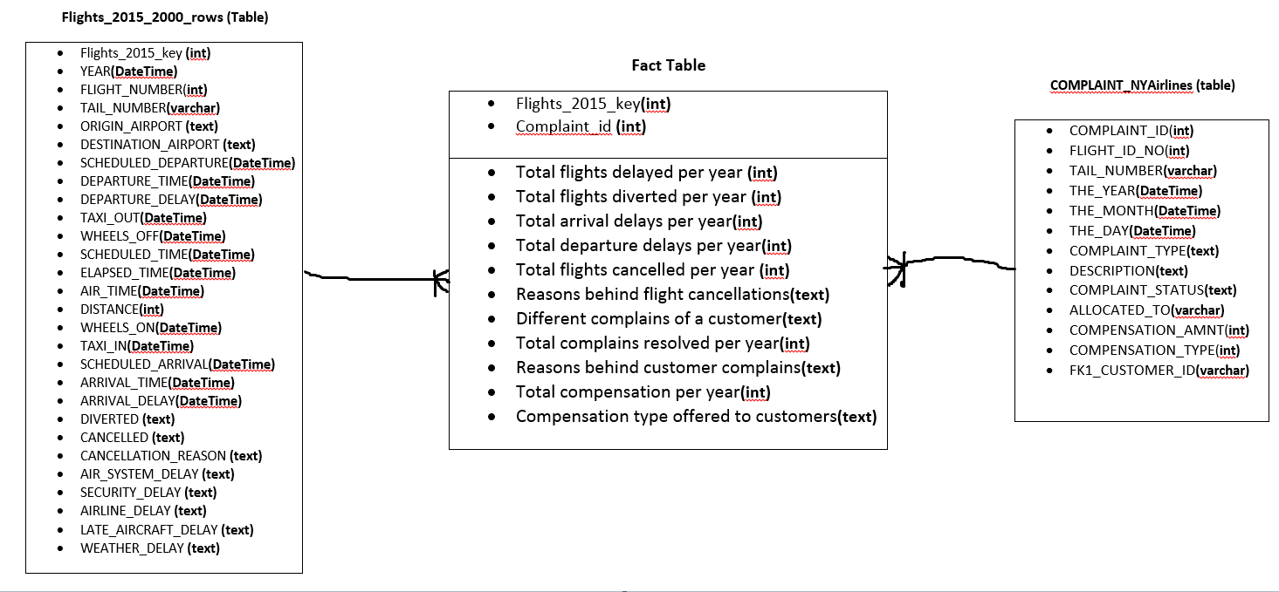

**Project Ended**